Impact of Price and Delivery Time on Consumer Choice: Experimental Insight from Indian Q-commerce Platform
Sakshi Baheti, Department of Computer Science, IIS (Deemed to be University), Jaipur
Dr. Preeti Tiwari, Associate Professor, International School of Informatics & Management, Jaipur

Abstract
Changes in the ways in which customers engage with an online channel, especially in terms of product pricing and delivery models, have quickly advanced due to the rapid growth of e-commerce in India. Instamart, Blinkit and Jiomart are the main competitors competing for customers. As the emotion and rationality of understanding the determinants of consumer behaviour increasingly influence business strategy and academic research. Price sensitivity and time of delivery are two overarching factors affecting consumers in the competitive landscape of digital commerce as dynamic pricing and instant delivery makes the traditional methods of how consumers purchase obsolete.
Building on this background in relation to our study, the current work uses transaction-level data from top Indian e-commerce platforms to analyze the effects of product price and delivery time on consumer choice in a step-wise fashion. The data includes a variety of factors, and product specific attributes, delivery times, ratings and feedback were considered. Different analytical techniques were utilized to analyze the interrelation of these factors and how they vary across different platforms and product types, including exploratory data analysis, hypothesis testing, and predictive modelling. New e.g., delivery time speed and calculation of percentage discount features are introduced to provide additional understanding of consumer choice behavior for the research.
The objective of this research paper is to measure both the relative importance of price and delivery time in purchase likelihood on Instamart, Blinkit, and Jiomart, as well as to measure customers’ sensitivity to price and delivery time by platform and category. Our findings should lead to practical recommendations for e-commerce companies on how to structure their prices based on customer delivery time and payment sensitivity. The objective of this research paper is to measure both the relative importance of price and delivery time in purchase likelihood on Instamart, Blinkit, and Jiomart, as well as to measure customers sensitivity to price and delivery time by platform and category. Our findings should lead to practical recommendations for e-commerce companies on how to structure their prices based on customer delivery time and payment sensitivity.
Keywords: Q-commerce, Consumer Choice, Price Sensitivity, Delivery Time, Instamart, Blinkit, JioMart
- Introduction
Seeing the rise of Q-commerce in India and the rapid expansion of the Indian retail landscape propelled by E-commerce, it's clear that the expectations and behavior of consumers are changing due to Q-commerce's ultra-rapid delivery promises. Competing for the market share in this space are the likes of Instamart by Swiggy, Blinkit by Zomato and JioMart by Reliance. Ultimately, the player that successfully optimizes pricing and logistical efficiencies will win this competition. This introduction will provide the necessary groundwork to explain the evolution of the Q-commerce sector, explain the challenges that complex pricing systems will pose to Q-commerce, and unpack the consumer decision-making process that incorporates a delivery time.

Expecting delivery of everyday items in Q-commerce in as little as 10 to 30 minutes cemented the principles of ultra-fast delivery services that the Q-commerce industry promises. Q-commerce gained prominence in the pandemic period when consumers were looking for safe and convenient means of obtaining groceries and other essentials. The industry has three core components: Dark Stores which are Micro-warehouses positioned in close range to urban centres and designed to perpetually maximize delivery speeds across short distances, and AI-Enabled Logistics which utilizes advanced technology to oversee stock control, and predict and adapt to rapid stock movements.

Delivery time is a key element of Q-commerce and possibly the most important driver of customer behavior and satisfaction. The concept of “10-minute delivery” has resulted in an expectation for near-immediate gratification, with delivery speed emerging as a primary influencer in platform selection.

Consumer research on Q-commerce use indicates ultra-fast delivery is an important attribute in informing consumer choice. The benefit of receiving products in near real time satisfy unplanned need and meet an impulse purchase need, which e-commerce or brick and mortar retail cannot compete with.

- Literature Review
This endeavor builds upon a growing body of literature on consumer behaviour in e-commerce, and more recently, in the sub-field of Q-commerce. The table below highlights some key studies according to their methods and identifies legitimate gaps in the literature this study seeks to fill.
Paper Title | Author(s) | Year | Methodology | Observation/Research Gaps
Drivers of change to e-grocery: an investigation | H. Alkhiyamiet al. | 2025 | Survey-based  segmentation and factor analysis of e-grocery consumers. | Identifies price, delivery price, and lead time as major influencers of choice. The research only covers groceries and does not consider additional product categories.
A Study on Analysis of Factors Influencing Delivery Time Preference & Customer Repurchase Intention for E-Tailing Websites | P. Chaturvedi & D. Agnihotri | 2019 | Primary survey of Indian buyers with regression analysis. | Discoveries that good quality, packaging and discounts can reduce the negative effects of delivery delays. There is no systematic evaluation of the price and delivery time trade-off across different categories.
A Study on Factors Influencing Consumer Adoption of Quick Commerce in India | Sheikh, N., & Thakur, N. S. | 2025 | Survey analysis investigating attributes driving Q-commerce adoption. | Stresses the importance of ultra-fast delivery, price, and convenience. There is no behavioral research about the price and delivery trade-off.
Impacts of Delivery Charge on the Possibility of Consumers Choosing to Use OFD Service | Y. Wu et al. | 2022 | Logistic regression  analysis in the context  of Online Food Delivery (OFD) in China. | Notes delivery price can influence the likelihood of a consumer using a service. The focus is not the Indian market and the wider Q-commerce of goods.
Impact of perceived convenience, service quality and delivery time on customers’ satisfaction in OFD services | R. Chowdhury  et al. | 2023 | Customer satisfaction modeling, likely using Structural Equation  Modeling (SEM). | Delivery time, service quality, and price do influence satisfaction. The research only covers the OFD sector and not general Q-commerce.
Table 1: Comprehensive Literature Review

1. "Drivers of change to e, grocery: an investigation" by H. Alkhiyami et al. (2025)”
This research employs factor analysis and segmentation based on survey to gain insight into consumer preference of an electronic grocery market. The authors argue that price, delivery cost, and lead time are the three most significant factors that a consumer will consider if he/she decides to shop for groceries online. This article serves as an essential step in understanding the main variables that influence purchasing online and is, however, limited by a study that only concentrates on groceries and does not consider other product categories that are typical in Q, commerce. The results of the research confirm the critical roles of price and time, which are the core variables that this study addresses.
2. “A Study on Analysis of Factors Influencing Delivery Time Preference & Customer Repurchase Intention for E-Tailing Websites" by P. Chaturvedi & D. Agnihotri (2019)”
Using a primary survey of Indian customers and regression analysis, this article tries to understand how delivery time changes the intention of a customer to make a repeat purchase from e-tailing websites. One of the main findings is that a few such factors which are not related to time, for example, product quality, packaging, and exciting discounts, may soften the impact of a delayed delivery. This research, by demonstrating the complexity of the factors that influence customer satisfaction, leaves aside the question of how consumers directly trade off between price and delivery speed in different product categories, which is a point addressed by the present study.
3. “A Study on Factors Influencing Consumer Adoption of Quick Commerce in India" by Sheikh, N., & Thakur, N. S. (2025)”
This investigation based on surveys dives deep into the features that compel the customers to embrace Q, commerce in India. According to the authors, one of the main reasons that led to the consumer switch to the new retail model is the central role of ultra, fast delivery, competitive pricing, and general convenience. Nevertheless, the research's biggest limitation is that it lacks an experimental test; the paper recognizes the main factors but does not delve into consumer behavior when they have to choose between them, for example, whether they decide to prioritize speed over a lower price.
4. “Impacts of Delivery Charge on the Possibility of Consumers Choosing to Use OFD Service" by Y. Wu et al. (2022)”
The paper employs logistic regression to analyze the impact of delivery costs on a customer's probability of ordering online in the food delivery market in China. It concludes that delivery fees greatly reduce the chances of a customer choosing the service. Although the study offers convincing proof that the consumers are sensitive to the delivery price, the freight focus on the Chinese OFD market only allows very limited fringing Q, commerce of goods in the Indian context.

5. “Impact of perceived convenience, service quality and delivery time on customers’ satisfaction in OFD services" by R. Chowdhury et al. (2023)”
The research applies customer satisfaction modeling as the main tool to identify that these three factors: delivery time, service quality, and price, substantially influence customer satisfaction in the online food delivery sector. In fact, it confirms the notion of service being a multi, faceted entity where at least two of the facets, i.e., time and price, are still there. Nevertheless, the foremost problem of the paper is that its results only apply to the food sector, thus leaving the regular e, commerce of consumer goods, which are said to have different purchasing drivers and logistical complexities, still unexplored.
- Experimental Setup
This section details the dataset, hardware, software, and methodological process used to conduct the experimental research and exploratory data analysis.

  - About Dataset
Source of the Dataset: This data was analyzed using a simulated dataset titled "Ecommerce_Delivery_Analytics_New," which is publicly available via Kaggle. Over 100,000 transactions from three major Indian q-commerce platforms (JioMart, Blinkit, and Instamart) are included in this data set.

Data Fields: The data set has 11 columns of information for customer behavior analysis. The available information included: 'Order ID', 'Customer ID', 'Platform', 'Order Date & Time', 'Delivery Time (Minutes)', 'Product Category', 'Order Value (in INR)', 'Customer Feedback', 'Service Rating', 'Delivery Delay', and 'Refund Requested'.
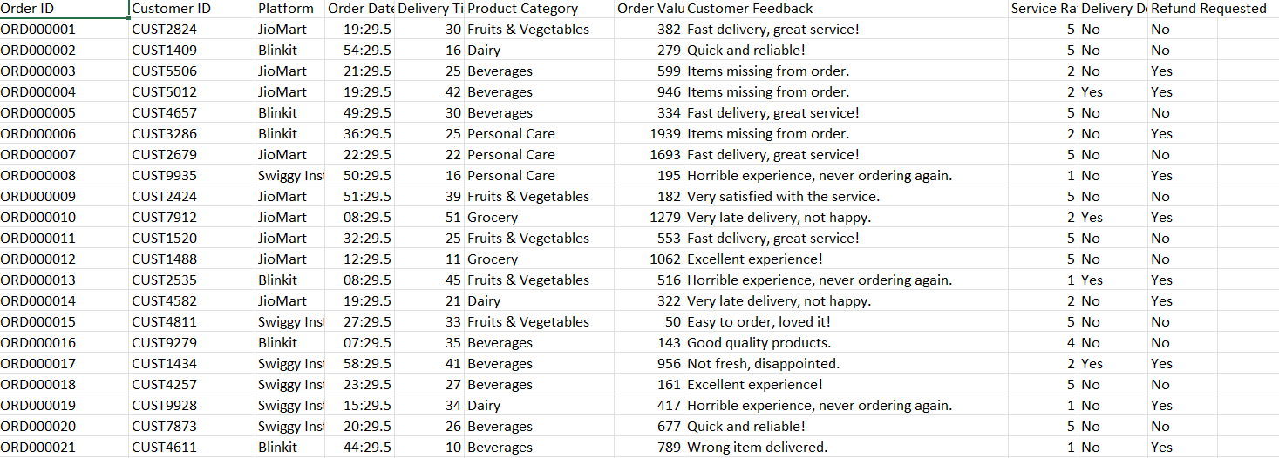
Figure 1: Snapshot of Dataset
  - Experimented Hardware, Software, and Process
The laptop on which this study's data analysis and experimental research were performed on 12th Generation Intel Core i5-12450H processor (2.00 GHz), 16GB RAM, and 64-bit Windows 11. Data analysis was done using Python 3.x in the Jupyter Notebook application, which was also used for writing and running the code and documenting the study's research workflow. For data manipulation, analysis and visualization which included the use of charts and graphs, the main Python libraries used were matplotlib, seaborn, pandas, and numpy. This configuration supported the research and provided the requisite insight on the effect of price and delivery time on Indian Q-commerce market.

Process:-
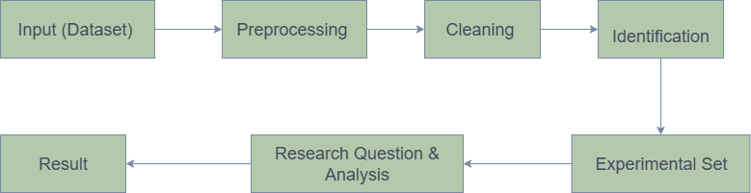
Figure 2 : Methodology
  - Research Question
This study is guided by ten key research questions designed to deconstruct consumer behavior and platform performance in the Indian Q-commerce market. The significance of each question lies in its ability to provide actionable insights for business strategy, operational improvements, and competitive positioning.
RQ | Question | Significance
RQ1 | Which Q-commerce platform has the highest order rate? | Measures market share and brand dominance, providing a clear benchmark for competitive analysis.
RQ2 | Which category of items is most ordered? | Identifies core consumer needs and demand patterns, informing inventory management, marketing focus, and supply chain priorities.
RQ3 | Which category takes more time in delivery? | Pinpoints operational bottlenecks and logistical  challenges, highlighting areas where service improvements can enhance customer satisfaction.
RQ4 | What category has the maximum  order value by customers? | Reveals which product categories attract high-spending customers, guiding strategies for premium product placement and upselling.
RQ5 | Which platform has the maximum refund requests? | Acts as a critical indicator of customer dissatisfaction and operational failures (e.g., poor product quality, incorrect orders, or delivery issues).
RQ6 | Which is the best app according to customer feedback and ratings? | Measures overall customer satisfaction and brand  loyalty, offering a qualitative view of platform performance beyond just transactional data.
RQ7 | How does order volume differ during different time slots of the day? | Identifies peak and off-peak hours, which is essential for optimizing resource allocation, staffing delivery riders, and implementing dynamic pricing.
RQ8 | Which category contributes the most revenue across platforms? | Determines the most financially significant product categories, helping businesses focus their strategic efforts on areas with the highest profitability.
RQ9 | Which time slot has the highest  number of refund requests? | Correlates operational stress with service failures, helping to identify specific times when quality control and support are most needed.
RQ10 | Do customer preferences for product categories vary by platform? | Explores potential market differentiation and whether consumers associate specific platforms with certain product types, informing niche marketing strategies.

- Result & Discussion
The outcomes for each of the ten research questions are outlined in this part, alongside the visualized data and tables that are the results from the Q, commerce dataset analysis. Every sub, section gives the exact response to the question and a short talk of its strategic implications.

4.1 Which Q-Commerce platform has the highest order rate?

Result : Evidence from the study demonstrates a very slim race to dominate the market in relation to three main platforms. Swiggy Instamart has a marginal advantage with 33,449 orders, but basically they all had order volumes that are similarly sized, indicating the competitive dynamics of the Indian Q-commerce market.

Discussion: The similar volume of orders between both platforms suggests that neither established market dominance or a solid lead over the other. Customer loyalty is fluid and customers may switch apps based upon availability, discounts for their order, or even their perception of delivery speed at the moment they place the order. For operators, this reinforces the need for consistent performance and continuous improvement and effort to establish and maintain marketshare.
Platform | No. of Order
Instamart | 33,449
Blinkit | 33,424
JioMart | 33,127

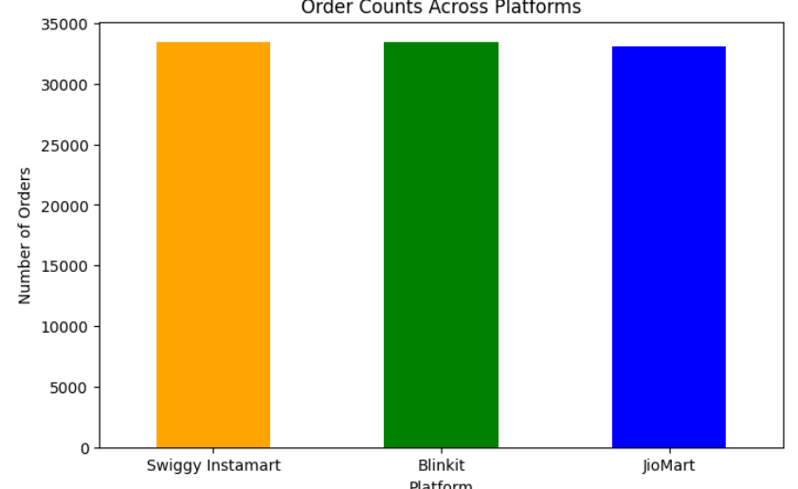
Table 3: highest order rate
Figure 2 : Order count across Platform
The x-axis represents the Platform, y-axis mesures the number of Order. The bar values are: instamart (33,449) ,Blinkit (33,424) and Jiomart (33,127)

4.2 Which category of items is most frequently ordered?
Result: Most consumer purchases on Q-commerce portals consist of basic household items. Within this category, Dairy is the top ordered item, followed by Groceries and Snacks. This still affirms our point that Q-commerce's key value proposition is centered around daily essentials.
Discussion: Identifying and anticipating demand for these items provides the opportunity for Q-commerce to gain/retain competitive advantage. Q-commerce is able to replace traditional top up trips to local stores. This provides an opportunity for these platforms to invest on sales forecasting that would improve the management of faster moving agile goods within the Q-commerce supply chain. From a marketing standpoint, the opportunity lies on pre-defined bundles for ordered frictional edge items. This would increase the average order value.

Product Category | No. of Order
Dairy | 16857
Grocery | 16737
Snacks | 16705
Fruits & Vegetables | 16632
Beverages | 16536
Personal Care | 16533
Table 3: mostly ordered item
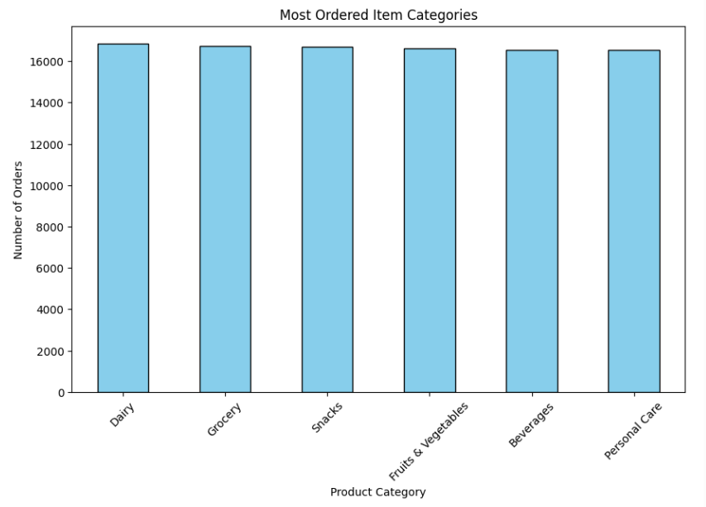
Figure 3 : : mostly ordered item
The a-axis shows the product Category, y-axis represents the no. of Orders. The bar values are approximately: Dairy (16,857), Grocery (16,737), Snacks (16,705), Fruits & Vegetables (16,632), Beverages (16,536), and Personal Care (16,533).
4.3: Which category takes more time in delivery?
Result: On average, Grocery and Personal care items take the more Delivery time. Meanwhile, Snacks and Beverages, which are typically impulse buys, are delivered marginally faster. Fruits & Vegetables have a better Delivery time, despite their perishability, likely because Delivery is prioritized.
Discussion: The extended delivery times in grocery are possibly related to the greater complexity associated with picking a multi-item order. As for personal care, the lack of optimized locations in a dark store may be contributing to delays. These observations indicate widespread elements of the overall operation which can be improved.
Product Category | Average Delivery Time (min)
Grocery | 29.58
Personal Care | 29.57
Dairy | 29.56
Fruits & Vegetables | 29.55
Beverages | 29.50
Snacks | 29.45
Table 4: Delivery Time by Category
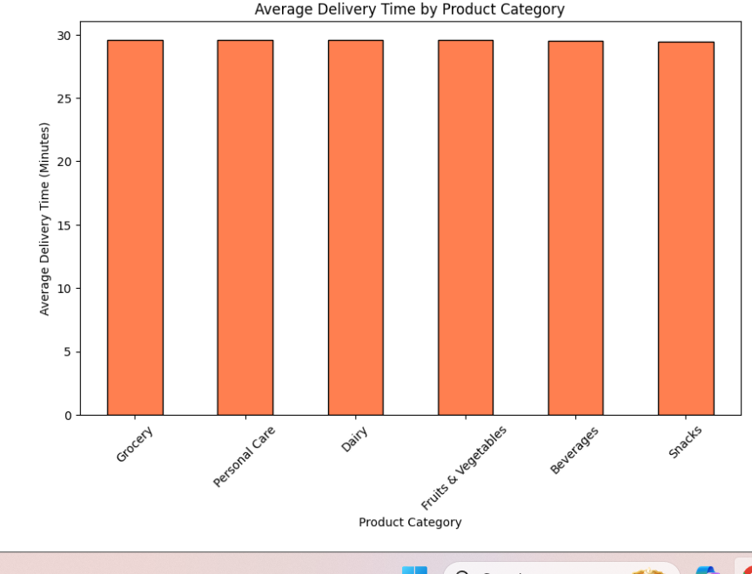
Figure 4 : Delivery Time by Category
This table has two column : product category and Average Delivery Time. The values show Grocery at 29.58 minutes, Personal Care at 29.57 minutes, and Snacks at the lowest with 29.45 minutes.

4.4 What category has the maximum ordered value by customers?
Result: The Personal Care category have highest maximum order values. The maximum order values of other categories such as Snacks is much lower.
Discussion: These findings indicate that essentials drive frequency, while the personal care category drives high-value transactions. It appears that consumers will pay more for self-care, wellness, and beauty product categories if it is convenient. For platforms, this presents an opportunity for platforms to grow their premium personal care category by increasing the size of their premium product offerings and leveraging targeted promotions to advertise the high-margins of their products.
Product Category | Max. Order Value (INR)
Personal Care | 2,000
Grocery | 1,500
Beverages | 1,000
Dairy | 800
Fruits & Vegetables | 700
Snacks | 500
Table 5: Max Order Value by Category
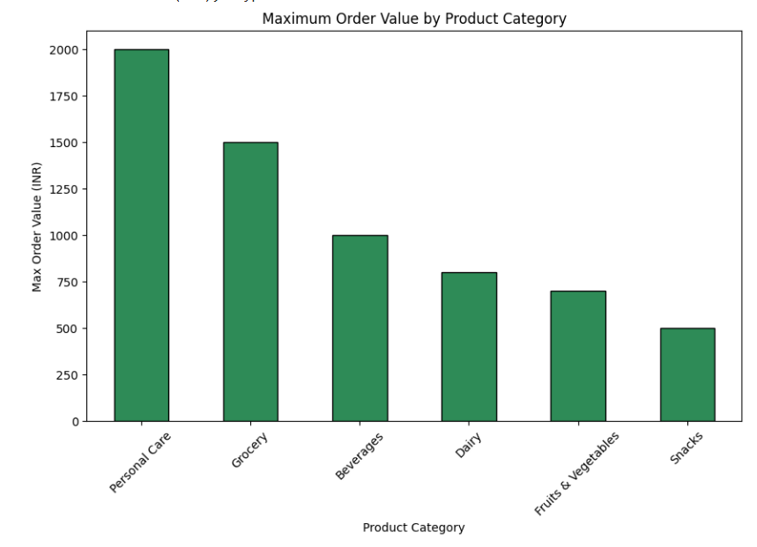
Figure 5: Max Order Value by Category
This table contains two columns: Product Category and Maximum Order Value (in INR). The values varies from highest at ₹2,000 down to the lowest at ₹500.

4.5: Which platform has the maximum refund requests?
Result: Blinkit has the most refund requests, is followed by Swiggy Instamart and lastly JioMart. Though there is no large differences, they suggest there may be differences in service quality or product consistency.
Discussion: A high volume of refund requests is a direct signal of operational incongruence and customer displeasure. This could be a symptom of Blinkit's aggressive speed focus, potentially leading to more mistakes. With Instamart, issues of refunds could point to challenges with product quality. The ability to decrease rates of returns is of great importance to profitability improvements and customer trust.
Platform | Refund Requests
Blinkit | 15,353
Swiggy Instamart | 15,288
JioMart | 15,178
Table 6: Refunds by Platform
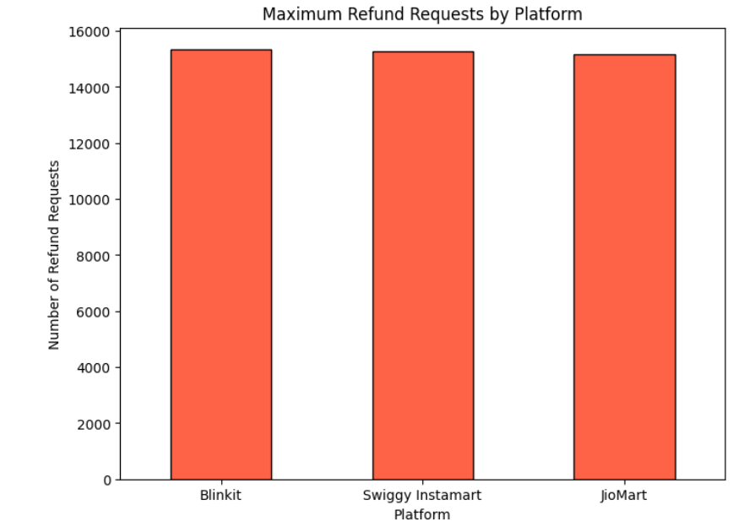
Figure 6: Refunds by Platform
The a-axis shows the Platform , y-axis represents the Refund Requests. The bar values are approximately: Blinkit (15,353), Swiggy Instamart (15,288), and JioMart (15,178).

4.6 Which is the best platform according to customer feedback and ratings?
Result: Even though the three platforms yield similar overall results, JioMart have a slightly higher percentage of positive feedback (54.152%). In absolute terms, however, Blinkit and Instamart received slightly more "Positive" reviews. Feedback volume for "Negative" and "Neutral" responses are also very close across all three platforms.
Discussion: These findings suggest that customer sentiment is relatively flat with no clear winning platform. While JioMart has a slight edge with the percentage of positive comments, the customer sentiment environment is largely competitive with all platforms clearly have at least a solid set of satisfied customers along with an equally steady base of detractors.
Feedback Category | Negative | Neutral | Positive | Total
Blinkit | 7,566 | 7,790 | 18,068 | 33,424
JioMart | 7,578 | 7,611 | 17,938 | 33,127
Instamart | 7,714 | 7,684 | 18,051 | 33,449
Table 7: Feedback by Platform
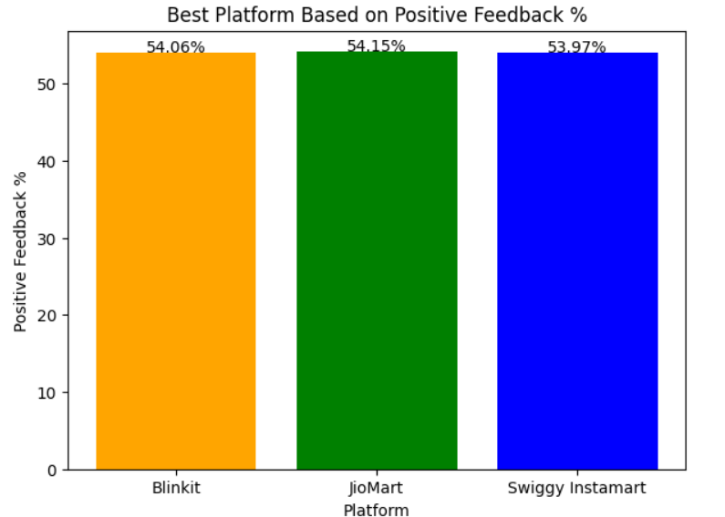
Figure 7: Feedback by Platform
The Pie Graph Shows Negative 7,566 (Negative), 7,790 (Neutral), and 18,068 (Positive), of overall customer Feedback Sentimental.

4.7 How does order volume differ during different time slots of the day?
Result : The time period for orders is primarily concentrated in the "Night" time period (presumably early evening to late night), accounting for just over 73,000 orders. The "Morning" is the second highest in order counts, while the afternoon and day hours capture substantially fewer orders.
Discussion: This pattern confirms that Q-commerce is primarily used for evening meal preparation, late-night snacking, and fulfilling needs that arise after the end of a typical workday. This has major implications for staffing, requiring a high density of delivery riders during peak night hours and more flexible staffing during quieter periods.
Time Slot | No. of Orders
Night | 73,567
Morning | 11,611
Afternoon | 8,095
Evening | 6,727

Table 8: Orders by Time Slot
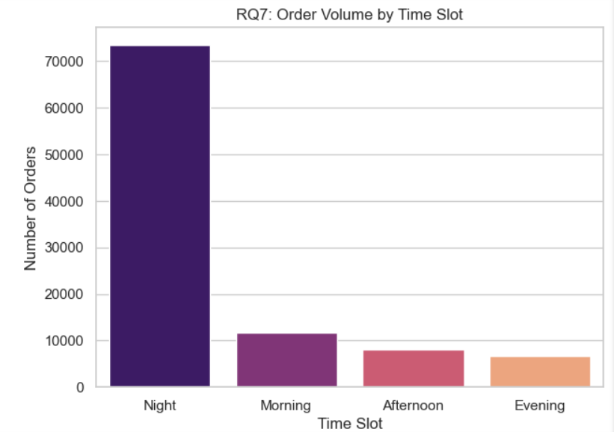
Figure 8: Orders by Time Slot
This table contains two columns: Time Slot and Number of Orders. The values shows Night slot with 73,567 orders, significantly more than the Morning slot with 11,611 orders.
4.8 Which category contributes the most revenue across platforms?
Result: Personal Care is highest revenue category, generating over ₹17 million, followed closely by Grocery. While Snacks are a high-frequency purchase, the Snacks category generated the smallest revenue of the major categories listed.

Discussion: This finding confirms the strategic importance of Personal Care. While essentials help drive user engagement, high-value personal care products help drive profit margins. Platforms should focus on expanding their mix in the Personal Care category, and focus on promoting the category in order to maximize revenue overall.
Product Category | Revenue (INR)
Personal Care | 17,395,601
Grocery | 14,194,055
Beverages | 9,086,669
Dairy | 7,610,522
Fruits & Vegetables | 6,246,517
Snacks | 4,566,076

Table 9: Revenue by Category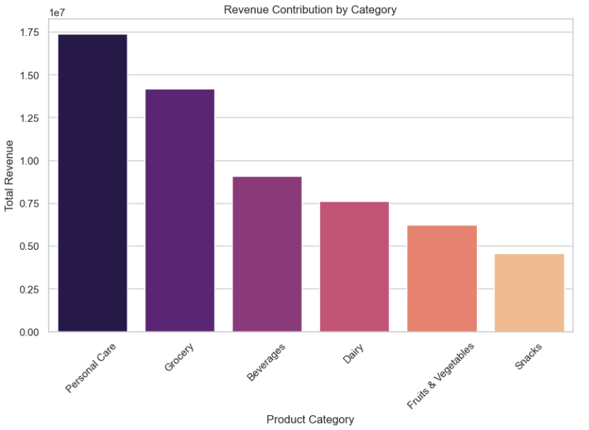
Figure 9: Revenue by Category
This table contains two columns: Product Category and Revenue (in INR).The values show Personal Care generating the most revenue at ₹17,395,601, followed by Grocery at ₹14,194,055.
4.9 : Which time slot has the highest number of refund requests?
Result: Similar to order volume, "Night" also has the largest number of refund requests. The volume of refunds in this peak period is over six times the next highest period (Morning).

Analysis: The relationship between peak hours and higher refund rates indicates the burden of busy periods causes more errors (e.g. wrong items, damages, delays). This is an area for improvement; investing in better quality control and support during night hours could drastically improve costs and customer retention.
Time Slot | Refund Requests
Night | 33,740
Morning | 5,317
Afternoon | 3,714
Evening | 3,048

Table 10: Refunds by Time Slot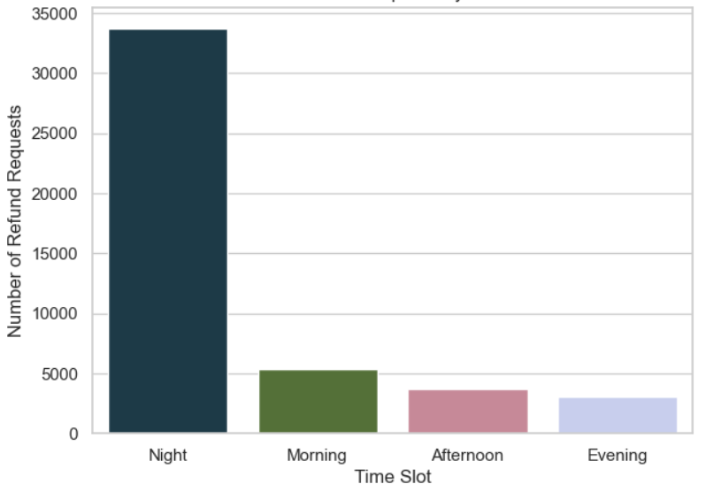
Figure 10: Refunds by Time Slot
This table contains two columns: Time Slot and Refund Request. The values the night slot has higest number of refund at 33,740, compared to morning slot’s 5,317.
4.10: Do customer preferences for product categories vary by platform?
Results: The data indicates a strong consistency in order distribution by product category across all three platforms. This does not reflect strong evidence of consumer associations of a product type with a platform.
Discussion: This consistency suggests that customers consider the three platforms to be largely interchangeable for any general basket of goods. While this complicates product endorsement, it also offers opportunity. For example, the platforms might seek to establish an endorsed reputation in a high-value specialty or niche (e.g., organic produce, luxury personal care line) to denote a unique quality of service to its brand and serve a specific type of loyal customer. At the moment, it appears that the competition focuses on an overall service metric rather than a special service.
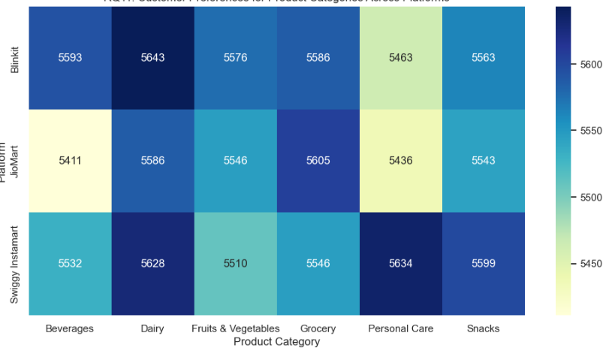
Figure 11: Category Preference by Platform
So basically, a grouped or stacked bar graph could visually display this information, where the x, coordinate would be Product Category, and the y, coordinate would be Number of Orders. In addition, the different color bars could represent different platforms. From the figure, we can observe that for each category the bars of the three platforms have almost the same length, which shows that the distribution is quite uniform.
- Conclusion

This study aimed to research how price and delivery time influence consumer choice in the ever-changing Indian Q-commerce market. From investigating more than 100,000 transactions from Swiggy Instamart, Blinkit, and JioMart, I can confirm that the three brands are at the center of an ultra-competitive industry where success relies heavily on operational quality and an understanding of consumer behavior. Although speed is often touted as the foundation of Q-commerce, the findings from our study reveal more complexities in that price, product category, and level of service quality are also equally as critical.

All three brands have not reached absolute domination; they are co-existing in a tie for market share and consequently, differentiation is an important part of their strategy. The composite score considered both delivery time, customer ratings and overall rating sentiment weightings revealing that Swiggy Instamart is the marginal leader and balances speed and customer satisfaction versus its competitors.

- Market is a Dead Heat: Similar volume of orders in Instamart, Blinkit and JioMart category suggest a fragile brand loyalty. Users likely use platforms that work for them in the moment of their needs, indicating that operational integrity looms larger than brand identity alone.

- Essentials Drive Frequency, Premium Drives Profit: Most common ordering items were dairies and groceries, both of which fall under the Essentials category, which drive user engagement, repeat opportunity and habit development and consolidation. But, the largest total dollar volume and maximum order values come from Personal Care; there is an opportunity to develop better profitability by expanding the range of high margin premium products and advocate for rate and restables

- Peak Hours Serve us Bone & Thumbs: Freshly orders most concentrated in Night time, validating that Q-commercial serves evening and late evening needs. The concern is, this peak order is directly correlated with the highest volume of refunds, suggesting that operating systems were under strain in responding to demand; leading to service failures as a group. Assigning greater quality control and an additional source of real-time support during peak order flows, presizing the great area for improvement.

- Speed of Delivery Isn't Everything: While speed of delivery is certainly part of the consumer expectation set, the analysis shows consumers have different levels of sensitivity to speed. The lengthy delivery times of complex grocery orders and the notable value of personal care products suggest consumers have a sophisticated, nuanced decision-making process. A strategy focused solely on "10-minute delivery" - or similar - across all products may be a bit inefficient; a more focused approach would be tiered delivery time based on product category and consumer urgency.

- Lack of Platform Distinction: Consumers appear to view the major platforms as relatively interchangeable, using them to purchase a similar basket of goods. The lack of platform differentiation presents a unique opportunity for a platform to gain consumer mindshare by specializing in a niche topic like organic, gourmet foods, or exclusive personal care brands and loyalty.
Ultimately, the future Q- commerce in India will be defined by more than just speed, but also reliability, strategic pricing, and ability to profitably meet diverse consumer needs. As the market matures, it will shift seamlessly from hypergrowth to operational efficiency and genuine customer loyalty.
6. Reference
- Alkhiyami, H., et al. (2025). Drivers of change to e-grocery: an investigation of consumers’ channel choice.
- Chaturvedi, P., & Agnihotri, D. (2019). A Study on Analysis of Factors Influencing Delivery Time Preference & Customer Repurchase Intention for E-tailing Websites. International Journal of Management Studies.
- Chowdhury, R., et al. (2023). Impact of perceived convenience, service quality and delivery time on customers’ satisfaction in OFD services
- Jarolia, P., et al. (2024). The Shift to Speed: A Case Study on the Rise of Q-Commerce Companies and Its Impact on E-commerce Strategies.
- Sachdeva, A., et al. (2022). Metaheuristic for Hub-Spoke Facility Location Problem: Application to Indian E-commerce Industry.
- Sheikh, N., & Thakur, N. S. (2025). A Study on Factors Influencing Consumer Adoption of Quick Commerce in India. ​
- Wu, Y., et al. (2022). Impacts of Delivery Charge on the Possibility of Consumers Choosing to Use OFD Service.

